Task-4 Advanced Filtering Techniques
Task A (Scalar Subquery): Find the team_id with maximum salary.
SELECT t.team_id, SUM(e.salary) AS total_salary
FROM team t
JOIN employee e ON e.team_id = t.team_id
GROUP BY t.team_id
ORDER BY total_salary DESC
LIMIT 1;

Explanation:
This task determines the team whose employees collectively earn the highest total salary. It calculates the sum of salaries for each team and identifies the team with the maximum combined salary.

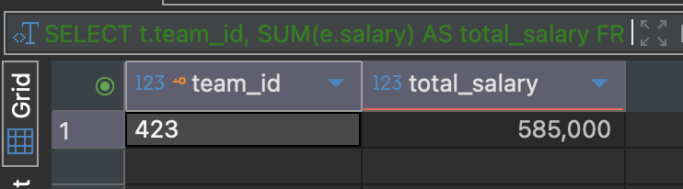

Task B(IN Clause): Give project names whose total working employee salaries exceed 1lakh.
SELECT p.project_name
FROM project p
WHERE EXISTS (
SELECT 1
FROM team t
JOIN employee e ON t.team_id = e.team_id
WHERE t.project_id = p.project_id
GROUP BY t.project_id
HAVING SUM(e.salary) > 100000
);

Explanation:
This task identifies projects where the total salary of all employees working on them exceeds 1 lakh. It aggregates employee salaries per project and returns only those project names that meet the specified salary threshold.


